The Gospel of John  
**6.1—GOD STILL PROVIDES – JOHN 6:1-15**

**LET’S OPEN OUR BIBLES TO JOHN 6**

**INTRODUCTION**

Many times to we find ourselves in situations where we––or other people––have a need, but there aren’t enough resources to meet the need. Today we’ll see that Jesus led the disciples into such a situation, and He tested them to see what they would do. How would they respond? What was their natural default? Would they look to God to help? Would they look somewhere else? Or would they just concede to the deficiency, and say, “I’m sorry, we can’t afford it.”

As usual, Jesus responds to the situation differently than His disciples. And by doing so, He teaches them how capable and willing God is to provide… when someone looks to Him.

You may not know it, but Jesus still leads us into such situations, and He tests us to see what we will do… what we really believe.

The title of today’s lesson is, “GOD STILL PROVIDES,” and I ask everyone to open your ears and hearts… and let Jesus show us––once again––who God is… and how willing He is to provide.

**LET’S READ JOHN 6:1-15**

**John 6:1–15 (ESV)** After this Jesus went away to the other side of the Sea of Galilee, which is the Sea of Tiberias. **2** And a large crowd was following him, because they saw the signs that he was doing on the sick. **3** Jesus went up on the mountain, and there he sat down with his disciples. **4** Now the Passover, the feast of the Jews, was at hand. **5** Lifting up his eyes, then, and seeing that a large crowd was coming toward him, Jesus said to Philip, “Where are we to buy bread, so that these people may eat?” **6** He said this to test him, for he himself knew what he would do. **7** Philip answered him, “Two hundred denarii worth of bread would not be enough for each of them to get a little.” **8** One of his disciples, Andrew, Simon Peter’s brother, said to him, **9** “There is a boy here who has five barley loaves and two fish, but what are they for so many?” **10** Jesus said, “Have the people sit down.” Now there was much grass in the place. So the men sat down, about five thousand in number. **11** Jesus then took the loaves, and when he had given thanks, he distributed them to those who were seated. So also the fish, as much as they wanted. **12** And when they had eaten their fill, he told his disciples, “Gather up the leftover fragments, that nothing may be lost.” **13** So they gathered them up and filled twelve baskets with fragments from the five barley loaves left by those who had eaten. **14** When the people saw the sign that he had done, they said, “This is indeed the Prophet who is to come into the world!” **15** Perceiving then that they were about to come and take him by force to make him king, Jesus withdrew again to the mountain by himself.

V1.1 – “After this” – Let me explain…

* The feeding of the 5000 is the only significant miracle of Jesus that is told in all four Gospels.
* Therefore we have more details about this event from the other three Gospels, including, something significant that happened just before it. Let me read from:
  + Matthew 14:9–13 (ESV) And the king was sorry, but because of his oaths and his guests he commanded it to be given. 10 He sent and had John beheaded in the prison, 11 and his head was brought on a platter and given to the girl, and she brought it to her mother. 12 And his disciples came and took the body and buried it, and they went and told Jesus. 13 Now when Jesus heard this, he withdrew from there in a boat to a desolate place by himself. But when the crowds heard it, they followed him on foot from the towns.

V1.2 – “Jesus went away to the other side of the Sea of Galilee”:

* and now you know why… to rest physically and emotionally
* This was where a town called Bethsaida is, on the northeast side of the Sea of Galilee. Listen to:
* *Luke 9:10 (ESV) On their return the apostles told him all that they had done. And he took them and withdrew apart to a town called Bethsaida.*
* Bethsaida is a town where several of Jesus’ disciples were from––Peter, Andrew, James, John and Philip.

V2 – “And a large crowd was following him”

* He was crossing the Sea of Galilee very close to the northern shore, and the crowd could likely see His boat from the shore and were walking toward where He was heading

V3 – “Jesus went up on the mountain”

* Bethsaida is at the base of the hills of the Golan Heights **[see map]**

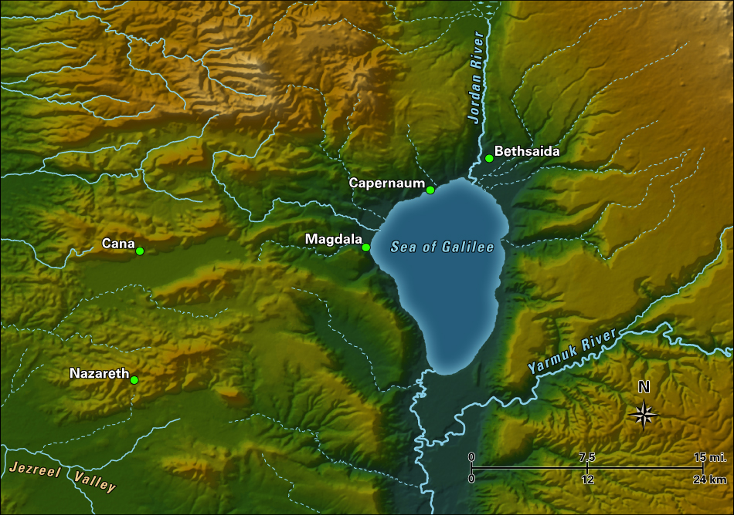

V4 – “Now the Passover, the feast of the Jews, was at hand.”

* Why is this in there? They’re not in Jerusalem where the Passover lambs will be sacrificed.
* If for no other reason, we know that this was late March or early April.

V5-6 – “Lifting up his eyes, then, and seeing that a large crowd was coming toward him, Jesus said to Philip, “Where are we to buy bread, so that these people may eat?” **6** He said this to test him, for he himself knew what he would do.”

* Jesus asked Philip… a native of that area… Philip knew that there was no place in that area that could provide enough food.
* Jesus tested His disciples, and He tests us.

V7 – Philip answered him, “Two hundred denarii worth of bread would not be enough for each of them to get a little.”

* Notice, Jesus asked Philip “WHERE” they could buy bread, and Philip shot back with, “We don’t have enough money.”
  + Isn’t that what we do to God?
* A denarius = 1 day’s wages
* 200 denarii – 200 day’s wages
* That’s over $20,000

Vs8-9 – “One of his disciples, Andrew, Simon Peter’s brother, said to him, **9** “There is a boy here who has five barley loaves and two fish, but what are they for so many?”

* The Greek word for “fish” = small cooked or pickled fish… this little boy’s mama seems to have prepared him some lunch.

V10.1 – “Jesus said, ‘Have the people sit down.’”

* Jesus is teaching us how to prepare for a miracle… you walk by faith.

V10.2 – “So the men sat down, about five thousand in number.”

* When you add women and children, there were probably 10,000 – 15,000 people.

V11 – “Jesus then took the loaves, and when he had given thanks, he distributed them to those who were seated. So also the fish, as much as they wanted.”

* **Mark 6:41 (ESV)** And taking the five loaves and the two fish, he looked up to heaven and said a blessing and broke the loaves and gave them to the disciples to set before the people. And he divided the two fish among them all.
* “as much as they wanted” = it was “all you can eat”

V12 – “And when they had eaten their fill, he told his disciples, “Gather up the leftover fragments, that nothing may be lost.”

* This shows us that God is provides abundantly
  + “My cup runs over” Psalm 23:5
* It also shows us what a good steward God is.

V13 – “So they gathered them up and filled twelve baskets”

* That’s a whole lot more than He started with.
* Is it interesting to you that there were 12 disciples and 12 baskets left over?

V14.1 – “When the people saw the sign that he had done”

* This miracle did not go unnoticed. The people knew, or realized, that this was a miracle.

V14.2 – “When the people saw the sign that he had done, they said, “This is indeed the Prophet who is to come into the world!”

* Moses said in Deuteronomy 18:15 (ESV) “The Lord your God will raise up for you a prophet like me from among you, from your brothers—it is to him you shall listen—
  + What did Moses do? What happened in the days of Moses? The people were provided bread—Manna—in the wilderness.
  + So the people realized that Jesus was a Prophet “like Moses.”

V15 – “Perceiving then that they were about to come and take him by force to make him king, Jesus withdrew again to the mountain by himself.”

* Notice “by force” = this was about to become something of a mob

**NOW Mark 6:32 says, (ESV)** And they went away in the boat to a desolate place by themselves.

1. Now where would Jesus get the idea that If there was a shortage of food for large crowd in a desolate place, God was willing and able to provide it?
2. And where did He get the idea that when there was a shortage of food or provision, God could give words of wisdom that would trigger the supernatural power of God to multiply the little provision that you have?

**HOW ABOUT THE STORY OF ELIJAH AND THE WIDOWED SINGLE MOTHER OF ZAREPHATH? A DROUGHT HAD CAUSED A FAMINE, AND SHE AND HER YOUNG SON WERE DOWN TO THEIR LAST HANDFUL OF MEAL AND JUST ENOUGH OIL TO MAKE THE LAST LOAF OF BREAD. LISTEN TO:**

**OR HOW ABOUT THE SINGLE MOTHER/WIDOW OF A PROPHET IN:**

**EX – Story of RETIRED MISSIONARY coming to Larry Burkett for advice. After coming off the mission field, he found he did not have enough income to make it back here in the US…**

**EX – Some years ago when there was a downturn in the economy, our church began to see it show up in people’s giving. In each of the months of September, October and November, our giving was over $100,000 short of our budget… $100,000 in each month. And if we had one more month like that, our reserves would be depleted and we’d be in the red. So now, in an Executive Team meeting in early December, the question arose, “Should we move forward with Christmas bonuses for the church staff?” The church staff works so hard, but we certainly don’t want to put the church in a difficult financial position. So we stopped to pray [that’s what you do when you don’t know what to do]. As I walked to the windows of our conference room and prayed, something came up in my spirit. So I walked back over to the Eteam and said exactly what I heard: “We have no evidence that God will not provide all of our needs this month.” So after deliberating together about the faithfulness of God, we decided to move forward with the Christmas bonuses in faith. What happened? We didn’t say a word to anyone but God… and He did it. Our December income covered all the expenses—including the Christmas bounses, and there was even $50,000 left over to take us into the new year. Because God is faithful… and He’s still providing for His people today.**

**EX – Here’s a recent testimony from a ministry called Children of the Nations.**



**Children of the Nations** is a Christian organization reaching orphaned and destitute children around the world.

Francisco is their spiritual care director in Malawi. When he was planning this year’s summer camp for primary school children, he knew he should plan for more children than usual because it was one of the first community events after the pandemic lockdowns. They typically had about 500 children at their camps, so Francisco planned for about 800.

However, about 1,800 children showed up to camp, more than twice what Francisco had anticipated. They had to somehow facilitate the same games, activities, and teachings as their normal camp.

**Here’s a picture of them teaching the kids:**

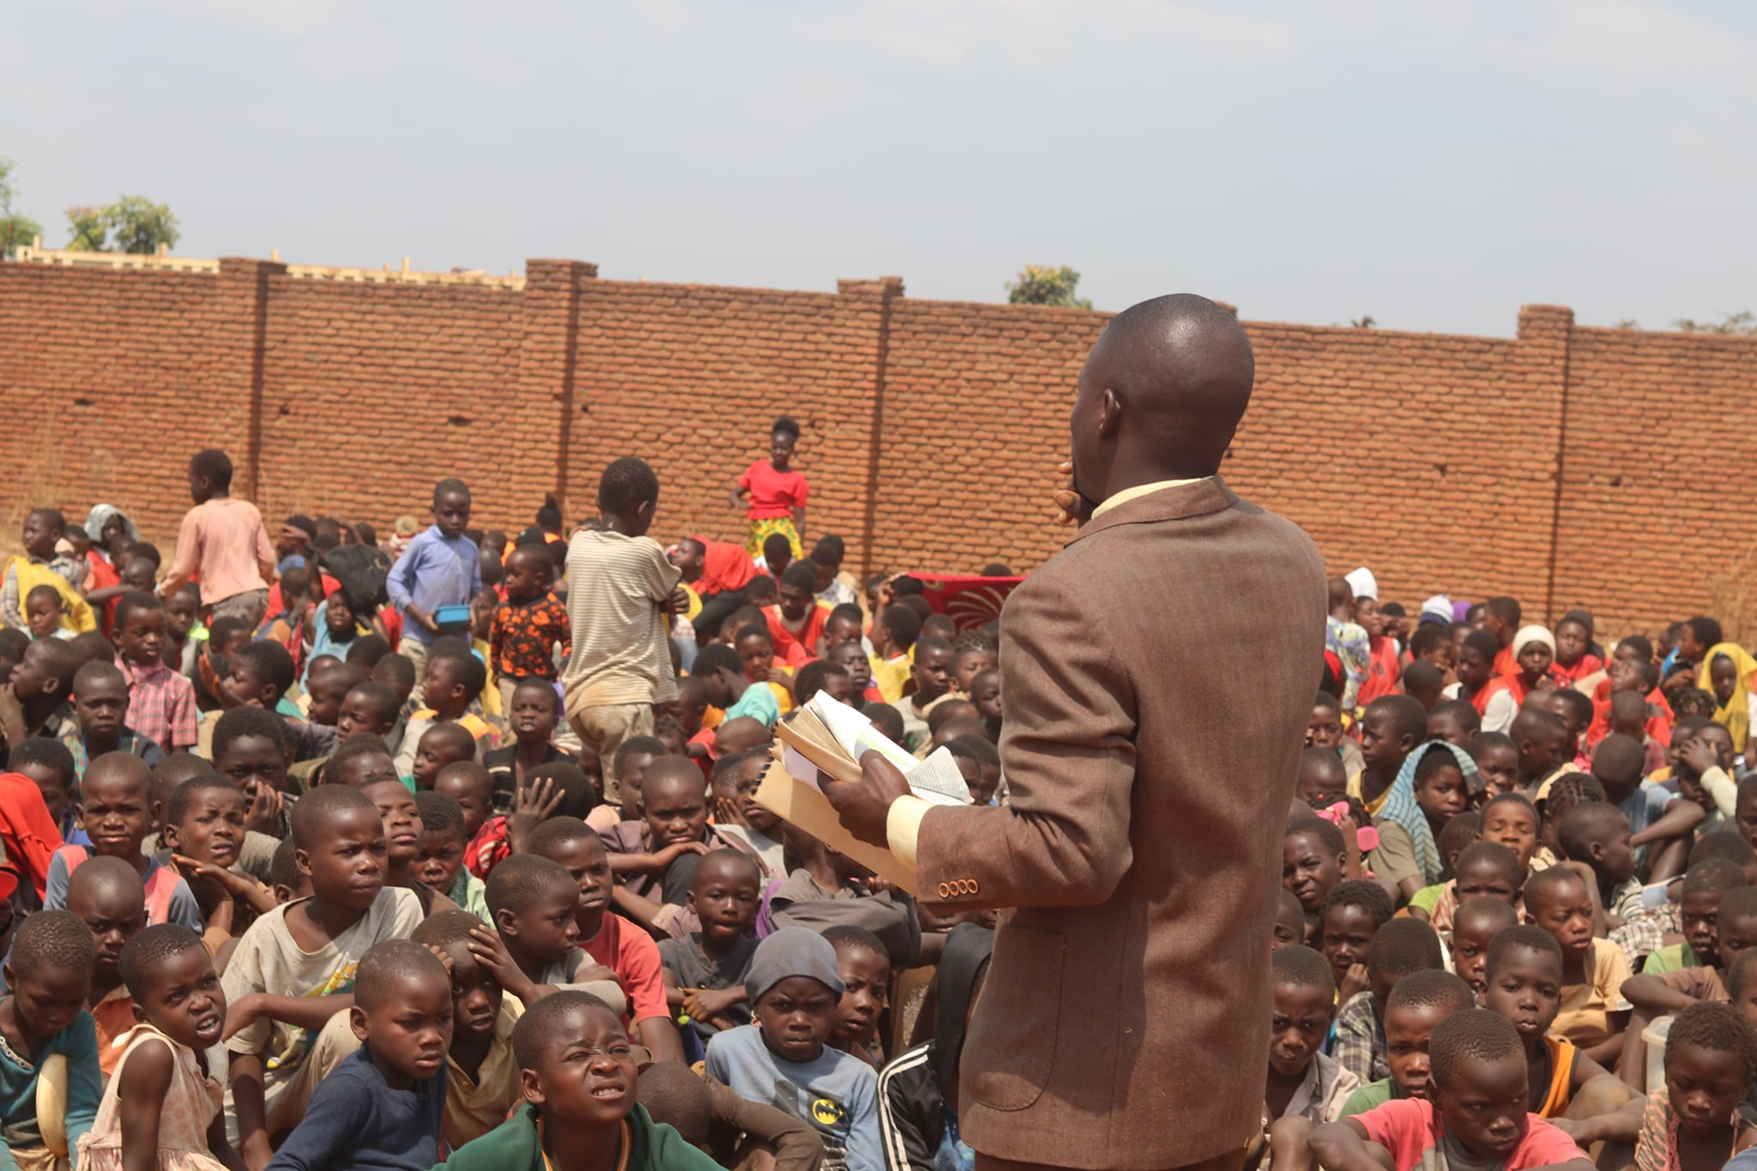

After the first teaching, it was then time to hand out food. Francisco had packed the truck with the food for that day himself, and he knew there was only enough for 800. How could they turn away 1,000 children?

**Look at these faces…**



But after handing out food to 800 children, there was still more food. They reached 1,000, and there was still more food. They reached 1,200, 1,500, 1,600, 1,700… and there was still more food … they fed all 1,800 children that day… because Jesus is still alive… and because there are people on the earth today that believe it.

We must trust God and give what we have by faith.