(Psalm 119) Luke 10

JOURNAL VIDEO

Screenshot #1
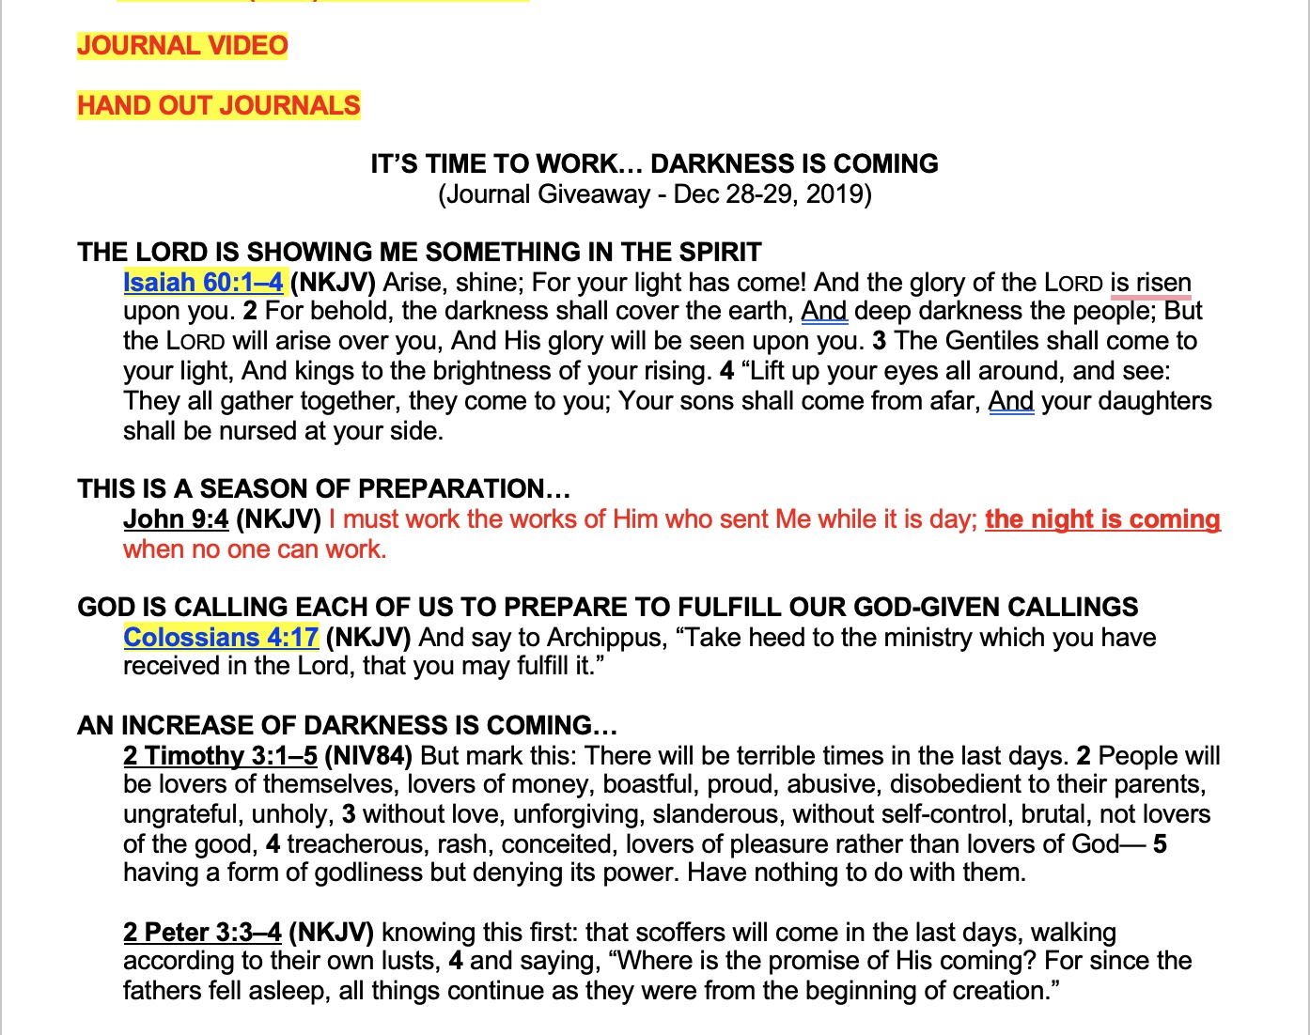

Screenshot #2
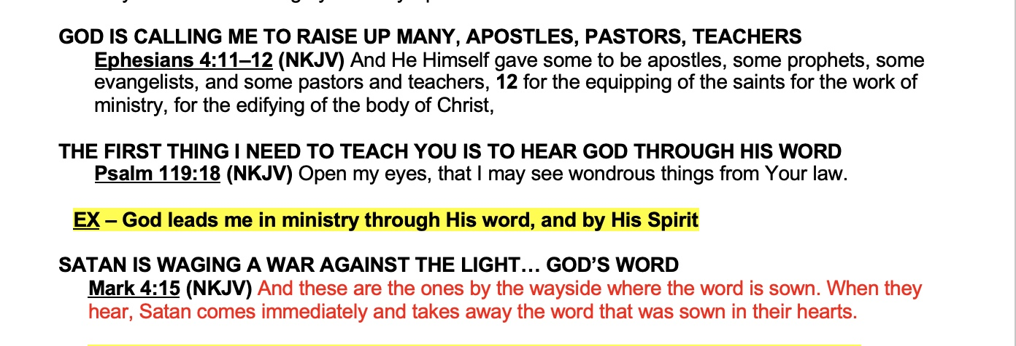

I PLAN TO SPEND THE NEXT SEVERAL DAYS FASTING AND PRAYING… SEEKING GOD ABOUT 2023… I’LL SHARE WHAT I HEAR ON VISION SUNDAY 2023.

HEARING GOD DAILY
(Journal Giveaway – January 1, 2023)

Luke 10:38–42 (NKJV) Now it happened as they went that He entered a certain village; and a certain woman named Martha welcomed Him into her house. 39 And she had a sister called Mary, who also sat at Jesus’ feet and heard His word. 40 But Martha was distracted with much serving, and she approached Him and said, “Lord, do You not care that my sister has left me to serve alone? Therefore tell her to help me.” 41 And Jesus answered and said to her, “Martha, Martha, you are worried and troubled about many things. 42 But one thing is needed, and Mary has chosen that good part, which will not be taken away from her.”

Proverbs 8:34 (NKJV) Blessed is the man who listens to me, watching daily at my gates, waiting at the posts of my doors.

WHOMEVER YOU LISTEN TO DAILY IS WHO YOU FOLLOW

GOD’S WORD SHINES SPIRITUAL LIGHT INTO OUR HEARTS AND MINDS

Psalm 119:130 (NKJV) The entrance of Your words gives light; it gives understanding to the simple.

EX – If your phone starts doing strange things, turn it off and power it back on. Why? Because it runs the designed programming.

HAVE YOU EVER HEARD OF A SOFTWARE DESIGNER?

GOD IS THE DESIGNER OF THE SOFTWARE OF OUR HEARTS AND MINDS… SO WHEN WE HEAR GOD SPEAK, WE BEGIN TO BE RECALIBRATED… REALIGNED… RESTORED… REFRESHED… AND RENEWED

Psalm 36:9 (NKJV) For with You is the fountain of life; In Your light we see light.

Psalm 119:105 (NKJV) Your word is a lamp to my feet and a light to my path.

EX – When I was about 20 years old, I really wanted to find my wife and get married… but the Lord spoke very powerfully to me through Proverbs 24:27 (NKJV) “Prepare your outside work, Make it fit for yourself in the field; And afterward build your house.”

EX – In February 2008, while negotiating a lease for 40,000 square feet to build a Worship Center, God spoke to me very powerfully through Exodus 34:10–12 (NKJV) And He said: “Behold, I make a covenant. Before all your people I will do marvels such as have not been done in all the earth, nor in any nation; and all the people among whom you are shall see the work of the Lord. For it is an awesome thing that I will do with you. 11 Observe what I command you this day. Behold, I am driving out from before you the Amorite and the Canaanite and the Hittite and the Perizzite and the Hivite and the Jebusite. 12 Take heed to yourself, lest you make a covenant with the inhabitants of the land where you are going, lest it be a snare in your midst.

EX – Then, in July of 2008, while on a Missions trip in Jinja, Uganda, the deal we had been negotiating for the Worship Center began falling apart… and while I was reading Isaiah 37 in my hotel room, I heard an email come through with a message that said, “the owner of the building said ‘forget it’ and walked away from the deal.” I read the email, and then continued reading Isaiah 37… and I read these words… Isaiah 37:14–17 (NKJV) And Hezekiah received the letter from the hand of the messengers, and read it; and Hezekiah went up to the house of the Lord, and spread it before the Lord. 15 Then Hezekiah prayed to the Lord, saying: 16 “O Lord of hosts, God of Israel, the One who dwells between the cherubim, You are God, You alone, of all the kingdoms of the earth. You have made heaven and earth. 17 Incline Your ear, O Lord, and hear; open Your eyes, O Lord, and see; and hear all the words of Sennacherib, which he has sent to reproach the living God… and Verse 21–34 (NKJV) Then Isaiah the son of Amoz sent to Hezekiah, saying, “Thus says the Lord God of Israel, ‘Because you have prayed to Me against Sennacherib king of Assyria, 22 this is the word which the Lord has spoken concerning him: … 23 “Whom have you reproached and blasphemed? Against whom have you raised your voice, And lifted up your eyes on high? Against the Holy One of Israel… Verse 29 Because your rage against Me and your tumult Have come up to My ears, Therefore I will put My hook in your nose And My bridle in your lips, And I will turn you back By the way which you came.” ’ … Verse 33 “Therefore thus says the Lord concerning the king of Assyria: … 34 By the way that he came, By the same shall he return…”

EX – In January 2009, when we were attempting to build out the Worship Center in about two months… and there was a lot of pressure to concede that we could not have our Dedication Service in it on March 29, 2009… but as I was reading Genesis 24, God spoke to me… personally… through verse 31. Originally it was Laban speaking to Abraham’s servant who was sent to find a wife for Isaac among the relatives of Abraham. In Genesis 24:31 (NKJV) Laban said, “Come in, O blessed of the Lord! Why do you stand outside? For I have prepared the house, and a place for the camels.”

YOU SEE… BY SPENDING TIME IN GOD’S WORD… LIGHT CAME ABOUT MY SITUATION AND I KNEW WHAT GOD WAS SAYING AND DOING

WHOEVER KNOWS WHAT GOD IS SAYING AND DOING HAS THE ADVANTAGE

Psalm 119:130 (NKJV) The entrance of Your words gives light; it gives understanding to the simple.

Psalm 36:9 (NKJV) In Your light we see light.

Psalm 119:105 (NKJV) Your word is a lamp to my feet and a light to my path.

LIGHT REVEALS PROBLEMS.

LIGHT REVEALS SOLUTIONS.

LIGHT REVEALS SIN AND MISTAKES.

LIGHT REVEALS SATANIC AND DEMONIC ACTIVITY.

LIGHT REVEALS GOD… GOD THE PERSON… HIS LOVE… HIS GOODNESS… HIS WISDOM… HIS POWER… HIS MAJESTY… HIS RIGHTEOUSNESS… AND HIS JUDGMENT.

LIGHT REVEALS GOD’S WISDOM AND PLAN.

Hebrews 4:12 (NKJV) For the word of God is living and powerful, and sharper than any two-edged sword, piercing even to the division of soul and spirit, and of joints and marrow, and is a discerner of the thoughts and intents of the heart.

NOTICE… IT PIERCES EVEN TO THE DIVISION OF SOUL AND SPIRIT… THE DIFFERENCE BETWEEN WHAT THE HOLY SPIRIT INSIDE YOUR SPIRIT IS SAYING AND WANTING AND WHAT YOUR OWN MIND AND EMOTIONS THINK AND WANT.

AND LOOK AT…

Hebrews 4:13 (NKJV) And there is no creature hidden from His sight, but all things are naked and open to the eyes of Him to whom we must give account.

GOD’S WORD SHINES GOD’S POWERFUL, SPIRITUAL SPOTLIGHT ON YOU, SHOWING YOU THAT EVERYTHING IS EXPOSED AND VISIBLE TO GOD. THIS CAUSES US TO REPENT AND MAKE NECESSARY ADJUSTMENTS, WHICH PREPARES US TO BE BOTH USED AND BLESSED BY GOD.

THE WORD OF GOD IS A SPIRITUAL CHIROPRACTOR… HEARING GOD’S WORD ALIGNS YOU TO GOD’S WILL, AND PLANS, AND THOUGHTS.

AS YOU HEAR GOD’S WORD THE FEAR OF THE LORD INCREASES IN YOU… THAT REVERENCE AND RESPECT FOR GOD THAT CAUSES YOU TO HUMBLE YOURSELF AND YIELD TO HIS WILL, SAYING, “NOT MY WILL BUT YOURS BE DONE.”

Isaiah 55:8–11 (NKJV) “For My thoughts are not your thoughts, Nor are your ways My ways,” says the Lord. 9 “For as the heavens are higher than the earth, So are My ways higher than your ways, And My thoughts than your thoughts. 10 “For as the rain comes down, and the snow from heaven, And do not return there, But water the earth, And make it bring forth and bud, That it may give seed to the sower And bread to the eater, 11 So shall My word be that goes forth from My mouth; It shall not return to Me void, But it shall accomplish what I please, And it shall prosper in the thing for which I sent it.

GOD’S WORD NOT ONLY PREPARES THE SOIL OF YOUR HEART, IT PLANTS AND CULTIVATES GOD’S WAYS AND THOUGHTS INSIDE OF YOU… SO THAT GOD’S WORD AND WILL COME TO PASS IN YOUR LIFE.

SO WE NEED TO READ GOD’S WORD AND LISTEN TO HIS VOICE

Psalm 119:18 (NKJV) Open my eyes, that I may see wondrous things from Your law.

TO WHATEVER DEGREE I HAVE BEEN SUCCESSFUL, THIS IS THE GREATEST SECRET OF MY SUCCESS… GOD LEADS ME THROUGH HIS WORD, AND BY HIS SPIRIT

2 Corinthians 4:3–4 (NKJV) “Our gospel… is veiled to those who are perishing, 4 whose minds the god of this age has blinded, who do not believe, lest the light of the gospel of the glory of Christ, who is the image of God, should shine on them.”

Joshua 1:8 (NKJV) This Book of the Law shall not depart from your mouth, but you shall meditate in it day and night, that you may observe to do according to all that is written in it. For then you will make your way prosperous, and then you will have good success.

EX - God encouraged me through Psalm 37 about replacing my car… verses like verses 3‬-5‬ Trust in the Lord, and do good; Dwell in the land, and feed on His faithfulness. Delight yourself also in the Lord, And He shall give you the desires of your heart. Commit your way to the Lord, Trust also in Him, And He shall bring it to pass. And verses 18‬-19‬ The Lord knows the days of the upright, And their inheritance shall be forever. They shall not be ashamed in the evil time, And in the days of famine they shall be satisfied.

EX - God spoke to me through Joshua 18…

Joshua 18:3 (NKJV) Then Joshua said to the children of Israel: “How long will you neglect to go and possess the land which the Lord God of your fathers has given you?

