**FUNNY –** Bessie Hendricks, the oldest person in the United States, died this past Tuesday, Jan. 3, at the age of 115 in Lake City, Iowa. But on her 112th birthday, she share three reasons she believed she lived so long… and I thought you’d like to hear what she said… The three reasons were… 1) hard work… 2) a reluctance to go to the doctor… and 3) regularly eating pie and cake.

REMOVING THE BIGGEST MOUNTAINS (series)

**1— REMOVING THE BIGGEST MOUNTAINS**

**Mark 11:12–14 (NKJV)** Now the next day, when they had come out from Bethany, He was hungry. **13** And seeing from afar a fig tree having leaves, He went to see if perhaps He would find something on it. When He came to it, He found nothing but leaves, for it was not the season for figs. **14** In response Jesus said to it, “Let no one eat fruit from you ever again.” And His disciples heard it.

**Mark 11:20–26 (NKJV)** Now in the morning, as they passed by, they saw the fig tree dried up from the roots. **21** And Peter, remembering, said to Him, “Rabbi, look! The fig tree which You cursed has withered away.” **22** So Jesus answered and said to them, “Have faith in God. **23** For assuredly, I say to you, whoever says to this mountain, ‘Be removed and be cast into the sea,’ and does not doubt in his heart, but believes that those things he says will be done, he will have whatever he says. **24** Therefore I say to you, whatever things you ask when you pray, believe that you receive them, and you will have them. **25** “And whenever you stand praying, if you have anything against anyone, forgive him, that your Father in heaven may also forgive you your trespasses. **26** But if you do not forgive, neither will your Father in heaven forgive your trespasses.”

**Matthew 21:21 (NKJV)** So Jesus answered and said to them, “Assuredly, I say to you, if you have faith and do not doubt, **you will not only do what was done to the fig tree, but also if you say to this mountain**, ‘Be removed and be cast into the sea,’ it will be done.

**IS IT REALLY TREES AND MOUNTAINS JESUS IS CONCERNED ABOUT?**

**LISTEN TO…**

**1 Corinthians 9:9–10 (NKJV)** For it is written in the law of Moses, “You shall not muzzle an ox while it treads out the grain.” Is it oxen God is concerned about? **10** Or does He say it altogether for our sakes? For our sakes, no doubt, this is written, that he who plows should plow in hope, and he who threshes in hope should be partaker of his hope.

**ISN’T JESUS REALLY TEACHING US HOW TO REMOVE THINGS THAT ARE RUINING OUR LIVES?**

**SO WHY DID JESUS CURSE THE FIG TREE?**

**Luke 13:6–9 (NKJV)** He also spoke this parable: “A certain man had a fig tree planted in his vineyard, and he came seeking fruit on it and found none. **7** Then he said to the keeper of his vineyard, ‘Look, for three years I have come seeking fruit on this fig tree and find none. **Cut it down; why does it use up the ground?’** **8** But he answered and said to him, ‘Sir, let it alone this year also, until I dig around it and fertilize it. **9** And if it bears fruit, well. But if not, after that you can cut it down.’ ”

**THERE ARE THINGS IN YOUR LIFE THAT ARE SUCKING THE LIFE OUT OF YOU… THEY’RE USING UP YOUR TIME… YOUR FOCUS… YOUR ENERGY… YOUR CONFIDENCE… YOUR PEACE… YOUR JOY… ETC, ETC.**

**AND JESUS IS NOT ONLY TEACHING US THAT THEY NEED TO BE REMOVED… HE’S TEACHING US HOW TO REMOVE THEM.**

**THE WAY THIS SERIES CAME ABOUT…**

**2 Corinthians 10:3–6 (NKJV)** For though we walk in the flesh, we do not war according to the flesh. **4** For the weapons of our warfare are not carnal but mighty in God for pulling down **strongholds**, **5** casting down **arguments** and **every high thing** that exalts itself against the knowledge of God, bringing **every thought** into captivity to the obedience of Christ, **6** and being ready to punish all disobedience when your obedience is fulfilled.

**2 Corinthians 4:18 (NKJV)** while we do not look at the things which are seen, but at the things which are not seen. For the things which are seen are temporary, but the things which are not seen are eternal.

**Ephesians 6:12 (NKJV)** For we do not wrestle against flesh and blood, but against principalities, against powers, against the rulers of the darkness of this age, against spiritual hosts of wickedness in the heavenly places.

**‭‭Luke‬ ‭6‬:‭45‬ ‭(NKJV)‬‬** “A good man out of the good treasure of his heart brings forth good; and an evil man out of the evil treasure of his heart brings forth evil. For out of the abundance of the heart his mouth speaks.”

**Proverbs 4:23 (NLT)** Guard your heart above all else, for it determines the course of your life.

**EVEREST FROM BASE CAMP… AND FROM SPACE**

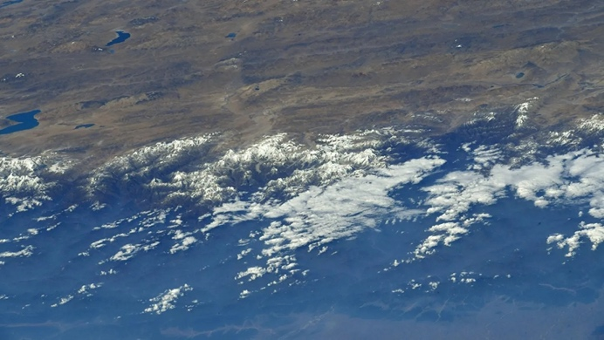

**IT’S ONE THING TO HAVE A THIEF PROWLING AROUND OUTSIDE TRYING TO GET INTO YOUR HOUSE… BUT IF THE THIEF GETS INSIDE… YOU HAVE A MAJOR PROBLEM**

**Matthew 6:23 (NASB 2020)** “…If the light that is in you is darkness, how great is the darkness!”

**JESUS IDENTIFIES A HUGE, DEADLY INVISIBLE MOUNTAIN IN MARK 11:25–26.**

**Mark 11:23–26 (NKJV)** For assuredly, I say to you, whoever says to this mountain, ‘Be removed and be cast into the sea,’ and does not doubt in his heart, but believes that those things he says will be done, he will have whatever he says. **24**Therefore I say to you, whatever things you ask when you pray, believe that you receive them, and you will have them. **25** “And whenever you stand praying, if you have anything against anyone, forgive him, that your Father in heaven may also forgive you your trespasses. **26** But if you do not forgive, neither will your Father in heaven forgive your trespasses.”

**IF GOD WON’T FORGIVE YOU, THERE ARE ALSO OTHER THINGS HE WON’T DO FOR YOU.**

**IF UNFORGIVENESS CONTINUES TO KEEP YOU FROM RECEIVING FROM GOD, IT’S A STRONGHOLD.**

**SO HOW DO YOU REMOVE UNFORGIVENESS?**

**JESUS SAID, “WHEN YOU STAND PRAYING… FORGIVE THEM… SPEAK FORGIVENESS WITH YOUR MOUTH AND BELIEVE YOU FORGIVE THEM IN YOUR HEART… THEN THE STRONGHOLD… THE BARRIER TO RECEIVING FROM GOD WILL BE REMOVED.**

**AND MANY CHRISTIANS DO NOT RECEIVE THE POWER AND PROMISES OF GOD BECAUSE OF THESE INVISIBLE MOUNTAINS**

**LET’S TALK ABOUT ANOTHER ONE…**

**1 John 1:9 (NKJV)** If we confess our sins, He is faithful and just to forgive us our sins and to cleanse us from all unrighteousness.

**UNCONFESSED SIN IS A STRONGHOLD… AND ONCE YOU CONFESS IT, HE FORGIVES YOU AND CLEANSES YOU… AND THR STRONGHOLD IS REMOVED.**

**PERVERSE MOUTH**

**EX - Even after God delivered me from lust, I had to remove the stronghold of sexual jokes and humor.**

**SO… I PLAN TO TAKE EACH ONE OF THESE AND TEACH YOU HOW TO REMOVE THEM:**

1. **STRONGHOLDS (addictions, bondages, curses, habits, hang-ups)**
2. **ARGUMENTS & ATTACKS (lies, fiery darts, temptations, unbelief)**
3. **THOUGHTS (fear, unbelief, natural thinking, guilt, shame, images, etc.)**
4. **SICKNESSES**