MORE IN 2024
“iwantmorein24.com”

Ephesians 2:10 (NKJV) For we are His workmanship, created in Christ Jesus for good works, which God prepared beforehand that we should walk in them.

1 Corinthians 9:24 (NKJV) Do you not know that those who run in a race all run, but one receives the prize? Run in such a way that you may obtain it.

LISTEN TO WHAT JESUS SAID THE NIGHT BEFORE HE DIED...

John 17:4 (NKJV) I have glorified You on the earth. I have finished the work which You have given Me to do.

LISTEN TO WHAT THE APOSTLE PAUL SAID SHORTLY BEFORE HE DIED...

2 Timothy 4:7 (NKJV) I have fought the good fight, I have finished the race, I have kept the faith.



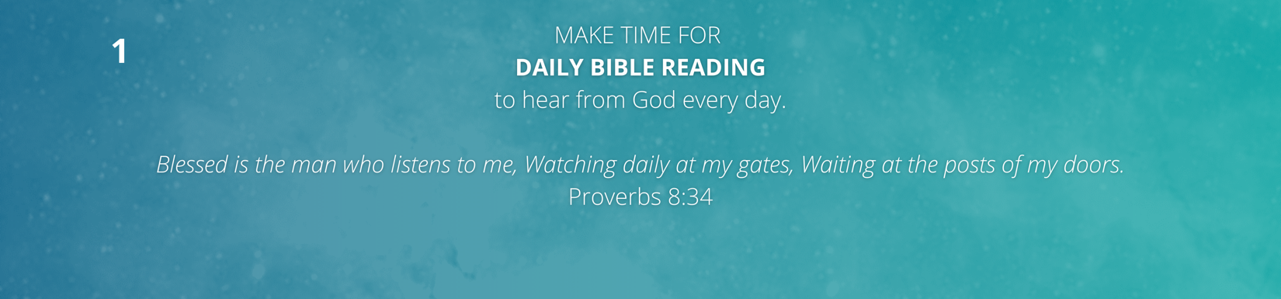

BIBLE READING PLANS

EX – JESUS DISCIPLE Reading Plans

PHONES + TABLETS
• YouVersion Bible App
• The Rock App
• Solid Lives App

WEBSITES
• Bible.com (YouVersion)
• gototherock.com
• solidlives.com

Psalm 36:9 (NKJV) For with You is the fountain of life; In Your light we see light.

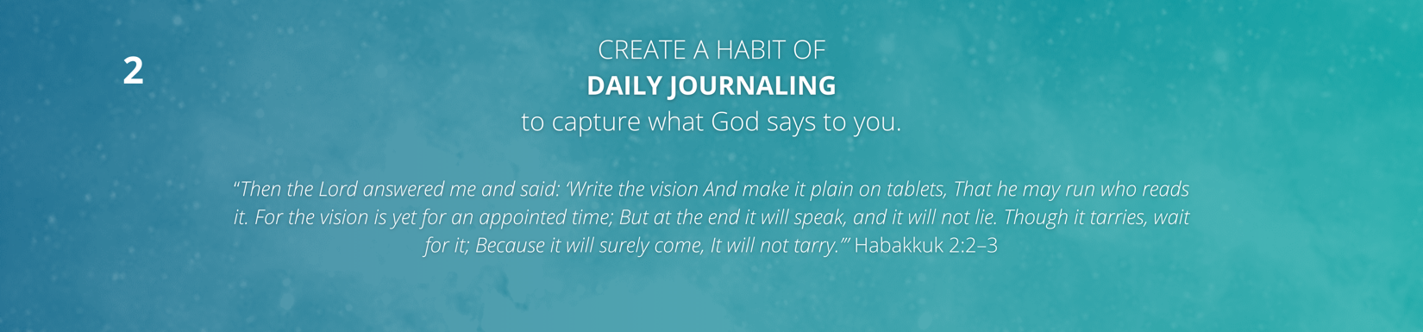

DIDN’T PRINT PAPER JOURNALS THIS YEAR... MORE PEOPLE USING ELECTRONIC VERSIONS

EX – I USE THE “DAY ONE” APP JOURNAL

