MINISTRY TIME SCRIPTURE (for Israel)

Psalm 122:6–8 (NKJV) Pray for the peace of Jerusalem: “May they prosper who love you. 7 Peace be within your walls, Prosperity within your palaces.” 8 For the sake of my brethren and companions, I will now say, “Peace be within you.”

Psalm 46:9–10 (NKJV) He makes wars cease to the end of the earth; He breaks the bow and cuts the spear in two; He burns the chariot in the fire. 10 Be still, and know that I am God; I will be exalted among the nations, I will be exalted in the earth!

OFFERING SCRIPTURE

Psalm 37:23–26 (NKJV) The steps of a good man are ordered by the Lord, And He delights in his way. 24 Though he fall, he shall not be utterly cast down; For the Lord upholds him with His hand. 25 I have been young, and now am old; Yet I have not seen the righteous forsaken, Nor his descendants begging bread. 26 He is ever merciful, and lends; And his descendants are blessed.

SRI LANKA

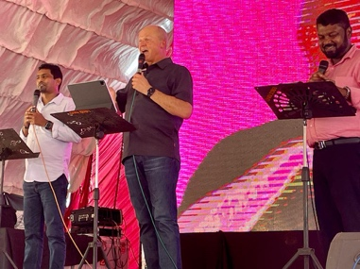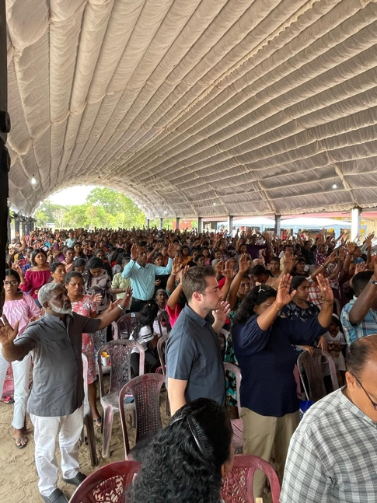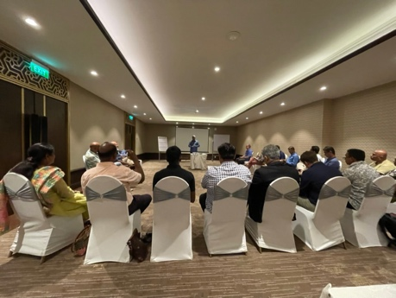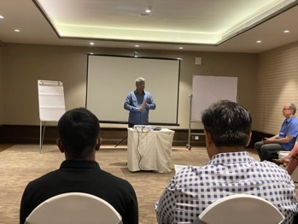
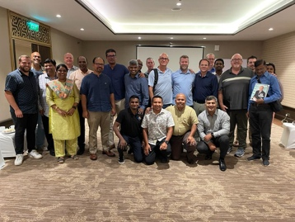
COLOMBIA
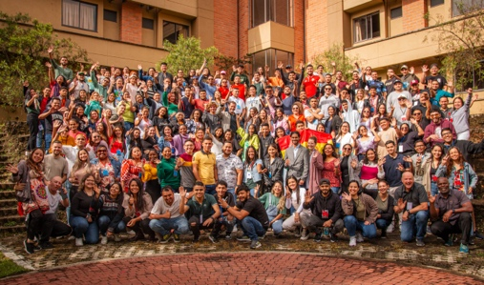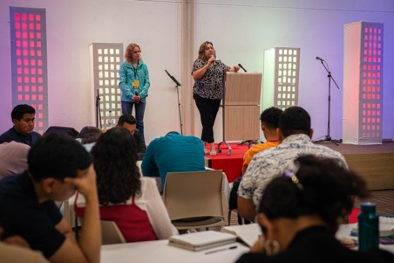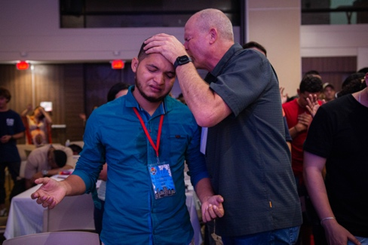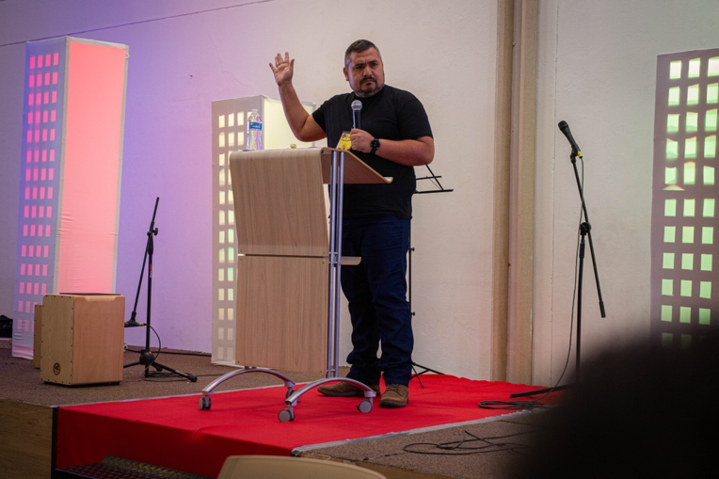

Doing the Impossible
1—YOUR IMPOSSIBLE CALLING

Ephesians 2:10 (NKJV) For we are His workmanship, created in Christ Jesus for good works, which God prepared beforehand that we should walk in them.

I WANT TO BEGIN WHAT I BELIEVE MAY BE A SHORT SERIES OR STUDY ON DOING THE IMPOSSIBLE. WE’LL LET THE LORD LEAD US… BUT TODAY, I FELT LED TO SHARE ABOUT FULFILLING YOUR IMPOSSIBLE CALLING.

LOOK AT THIS VERSE AGAIN. FOR WE ARE HIS WORKMANSHIP, CREATED IN CHRIST JESUS FOR SOMETHING… YOUR LIFE IS NOT RANDOM… YOU ARE A BELIEVER IN JESUS, AND YOU WERE CREATED IN CHRIST FOR SOMETHING SPECIFIC. WELL, WHAT IS IT? LOOK AT IT… YOU WERE CREATED IN CHRIST FOR GOOD WORKS. YOU WERE CREATED IN CHRIST TO DO GOOD WORKS. BUT NOTICE, THEY’RE NOT JUST ANY GOOD WORKS… THEY ARE SPECIFIC GOOD WORKS. LOOK AGAIN… YOU WERE CREATED IN CHRIST FOR GOOD WORKS, WHICH GOD PREPARED BEFOREHAND THAT YOU SHOULD WALK IN THEM. GOD PREPARED SPECIFIC GOOD WORKS FOR YOU TO DO… AND NOTICE… YOU SHOULD WALK IN THEM. GOD IS TALKING ABOUT A DIVINE PLAN… A LIFE OF SPECIFIC GOOD WORKS DESIGNED FOR YOU BY GOD.

AND LISTEN TO A FEW OTHER VERSES THAT GOD SPEAKS TO US. IN EPHESIANS 4:1 THE APOSTLE PAUL IS ADDRESSING EVERY BELIEVER IN THE CITY OF EPHESUS… AND BEING AND INSPIRED LETTER OF SCRIPTURE… GOD IS SPEAKING THIS TO US AS WELL.

Ephesians 4:1 (NKJV) I, therefore, the prisoner of the Lord, beseech you to walk worthy of the calling with which you were called.

SO NOTICE… YOU HAVE A CALLING FROM GOD WITH WHICH YOU WERE CALLED… AND HE IS INSTRUCTING YOU TO WALK WORTHY OF THAT CALLING. THAT WOULD INCLUDE LIVING YOUR LIFE WITH GODLY CHARACTER AND OBEDIENCE TO GOD IN GENERAL AS WELL AS BEING OBEDIENT AND DILIGENT TO FULFILL YOUR ASSIGNED CALLING.

NOW THESE WONDERFUL AND OFTEN-QUOTED VERSES. HOWEVER, THERE ARE SOME SIGNIFICANT INHERENT CHALLENGES:

- WHAT ARE THESE PLANS FOR YOUR LIFE AND MINE THAT GOD, IN HIS INFINITE WISDOM DESIGNED LONG AGO?

- HOW AND WHEN WILL WE FIND OUT WHAT THESE PLANS ARE?

- IF WE DO FIND OUT, WILL WE BE ABLE TO UNDERSTAND THEM SINCE WE DON’T HAVE THE WISDOM, UNDERSTANDING, AND PERSPECTIVE OF GOD?

- AND EVEN IF WE UNDERSTAND WHAT TO DO, WILL WE HAVE THE STRENGTH… THE COURAGE… THE RESOLVE… THE WILLINGNESS OF SELF-SACRIFICE… AND THE PERSEVERANCE TO FOLLOW THROUGH WITH IT?

- WHAT ABOUT ALL OF OUR CURRENT RESPONSIBILITIES? HOW WILL THEY BE TAKEN CARE OF… AND BY WHOM?

CAN YOU SEE THAT THE ODDS OF YOU FULFILLING YOUR DIVINE CALLING ARE NOT EVEN ONE IN A MILLION… THE ODDS ARE ZERO. IT’S IMPOSSIBLE. YOU, BROTHERS AND SISTERS, ARE CALLED TO ACCOMPLISH AN IMPOSSIBLE CALLING. JESUS SAID IN JOHN 15:5 …

John 15:5 (NKJV) Without Me you can do nothing.

WITHOUT ME YOU CAN DO… NOTHING.

HOWEVER… WHAT DOES PHILIPPIANS 4:13 SAY?

Philippians 4:13 (NKJV) I can do all things through Christ who strengthens me.

NOW NOTICE… THIS IS NOT MERELY A SELF AFFIRMATION. IT’S NOT SIMPLY SOMETHING SPIRITUAL TO SAY. NO. LOOK AGAIN AT THE LAST THREE WORDS, “WHO STRENGTHENS ME.” “WHO STRENGTHENS ME.” DO YOU SEE IT? JESUS WILL STRENGTHEN US SO THAT WE CAN DO THE IMPOSSIBLE. WE CAN DO IT BECAUSE JESUS CHRIST HIMSELF WILL STRENGTHEN US TO DO IT. HE WANTS US TO FULFILL OUR CALLINGS MORE THAN WE WANT IT.

SAY IT OUT LOUD WITH ME… “I CAN DO ALL THINGS THROUGH CHRIST WHO STRENGTHENS ME.”

SAY IT AGAIN…

AND LISTEN TO WHAT JESUS SAID IN MARK 9:23…

Mark 9:23 (NKJV) If you can believe, all things are possible to him who believes.

IF YOU CAN BELIEVE… ALL THINGS ARE POSSIBLE TO HIM WHO BELIEVES.

SAY THIS OUT LOUD…

I CHOOSE TO BELIEVE WHAT GOD IS SAYING TO ME…

SO I CAN FULFILL MY DIVINE CALLING FROM GOD.

OKAY, HOW DO WE DO IT?

LISTEN TO THE MESSAGE PAUL SENT TO A MAN NAMED ARCHIPPUS… A MESSAGE THE HOLY SPIRIT INSPIRED HIM TO WRITE BECAUSE IT’S ALSO A MESSAGE FROM GOD TO US. COLOSSIANS 4:17 SAYS…

Colossians 4:17 (NKJV) And say to Archippus, “Take heed to the ministry which you have received in the Lord, that you may fulfill it.”

NOTICE… TAKE HEED TO THE MINISTRY WHICH YOU HAVE RECEIVED IN THE LORD. SO AGAIN, YOU HAVE RECEIVED A MINISTRY IN THE LORD… YOU WERE CREATED IN CHRIST JESUS FOR GOOD WORKS… AND A BIG PART OF THOSE WORKS IS YOUR MINISTRY CALLING. AND GOD IS NOW COMMANDING… TAKE HEED TO YOUR MINISTRY CALLING THAT YOU MAY FULFILL IT. IF YOU DON’T TAKE HEED TO YOUR MINISTRY CALLING, YOU WILL NEVER FULFILL IT. IF YOU DON’T ACKNOWLEDGE THAT YOU HAVE A DIVINE CALLING, YOU CANNOT FULFILL IT. BUT NOW NOTICE… GOD IS SAYING VERY CLEARLY… IF YOU TAKE HEED TO IT… YOU CAN FULFILL IT. TAKE HEED TO THE MINISTRY WHICH YOU HAVE RECEIVED IN THE LORD THAT YOU MAY FULFILL IT. TAKE HEED TO IT… THAT YOU MAY FULFILL IT. TAKE HEED TO IT… THAT YOU MAY FULFILL IT.

SAY THIS OUT LOUD…

I ACKNOWLEDGE MY CALLING FROM GOD…

AND I TAKE HEED TO IT THAT I MAY FULFILL IT.

[REPEAT]

NOW… A BIG PART OF EVERY BELIEVER’S CALLING IS THE GREAT COMMISSION. THE GREAT COMMISSION WAS NOT GIVEN TO PASTORS… OR TO CHURCHES… IT WAS GIVEN TO EVERY FOLLOWER OF JESUS. AND THAT INCLUDES YOU AND ME.

JESUS SAID IN MATTHEW 28:19–20…

Matthew 28:19–20 (NIV) Therefore go and make disciples of all nations, baptizing them in the name of the Father and of the Son and of the Holy Spirit, 20 and teaching them to obey everything I have commanded you. And surely I am with you always, to the very end of the age.”

HERE AGAIN IS AN IMPOSSIBLE CALLING… MAKE DISCIPLES OF ALL NATIONS? REALLY?

BUT NOTICE… GOD IS SHOWING US TODAY HOW WE CAN FULFILL IT.

EX – HOW GOD TOOK A LUST-BOUND, INSECURE TEENAGER… AND TODAY DISCIPLESHIP IS TAKING PLACE IN MANY NATIONS.

NOW… LISTEN TO EPHESIANS 4:11–12…

Ephesians 4:11–12 (NKJV) And He Himself gave some to be apostles, some prophets, some evangelists, and some pastors and teachers, 12 for the equipping of the saints for the work of ministry, for the edifying of the body of Christ,

FOR THE EQUIPPING OF THE SAINTS FOR THE WORK OF MINISTRY… MINISTRY IS WORK… IT’S REQUIRES SACRIFICING OTHER THINGS… PREFERENCES… COMFORT.

BUT DID YOU KNOW THAT GOD IS WORKING TOO? THAT’S RIGHT… GOD IS ACTIVELY WORKING TO HELP US ACCOMPLISH OUR MINISTRY CALLINGS. LISTEN TO PHILIPPIANS 2:13…

Philippians 2:13 (NASB 2020) for it is God who is at work in you, both to desire and to work for His good pleasure.

